

COMPUTER STUDIES LESSON NOTES
PRIMARY THREE

TERM - 2015

Week 2

WORDPAD
What is WordPad?
WordPad is a basic program that you can use to create and edit documents.
Or WordPad is a computer program used to create, edit, view, and print text documents.
WordPad can help you type letters, book reports, and other simple documents.
How to open WordPad
1. Click Start
2. Click All Programs / programs
3. Click Accessories

4. Click WordPad.

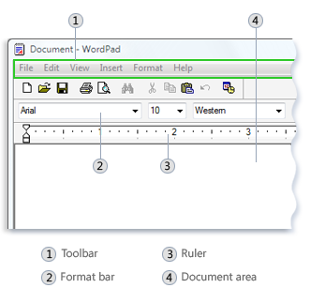
The WordPad window

There are four main parts of the WordPad window:
The toolbar
The toolbar contains buttons for basic commands, including saving and printing.

The format bar
The format bar contains buttons that you can use to format the text in your document. For example, you can choose the font, color, and alignment of your text.
The ruler
Use the ruler to check the plan and position of text in your document.
The document area
This is where you type your document, make changes to the text, and apply your formatting.

Typing text
A flashing vertical line called the cursor indicates where the next text that you type will appear in the document area.

Activities

Practice the learnt keys by typing these stories.

Activity 1

The Lion and the Mouse
Once when a Lion was asleep, a little Mouse began running up and down upon him. This soon wakened the Lion, who placed his huge paw upon him and opened his big jaws to swallow him.
"Pardon, O King!" cried the little Mouse, "Forgive me this time. I shall never repeat it and I shall never forget your kindness. And who knows, but I may be able to do you a good turn one of these days?"
The Lion was so tickled at the idea of the Mouse being able to help him, that he lifted up his paw and let him go.
Sometime later a few hunters captured the King and tied him to a tree while they went in search of a wagon to carry him on.
Just then the little Mouse happened to pass by, and seeing the sad plight in which the Lion was, ran up to him and soon gnawed away the ropes that bound the King of the Beasts. "Was I not right?" said the little Mouse, very happy to help the Lion.
MORAL: Little friends may prove great friends.

Activity 2

The Fox and the Stork
A selfish fox once invited a stork to dinner at his home and for a joke put nothing before her but some soup in a very shallow dish. The fox could easily lap this up, but the Stork could only wet the end of her long bill in it, and stayed hungry.
“I am sorry that the soup is not to your liking," said the fox with a sly smile.
"Oh, please do not apologise," said the Stork. "I hope you will return this visit, and come and dine with me too sometime." So a day was appointed when the Fox should visit the Stork.
Finally, when they were seated at the table, the Stork served them both some soup in a very long-necked jar with a narrow mouth. The stork drank the soup easily but the fox could not insert his snout into the tall jar. This time it was the Fox’s turn to go hungry.
MORAL: ONE BAD TURN DESERVES ANOTHER.

Selecting text or highlighting a text
1. Position the mouse pointer to the left of where you want to begin your selection.
2. Click and hold the left mouse button while you drag (pull) the pointer over the text that you want to select.
Note: The selected text will be highlighted. Once you've completed your selection, release the mouse button.
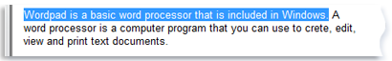

Copying a text

This means making a duplicate copy (second copy) in another place.

Steps
- Select the text to copy.
- Click Edit menu
- Click Copy.
- Move the cursor to the place where you want to insert (put) the copied text.
- Click Edit menu
- Click Paste.
Note
To quickly copy text that you've selected, press CTRL+C.
To paste it, press CTRL+V.

Moving a text to a different location
This means removing a text from its original place to another place.

Steps
- Select the text that you want to move.
- Click Edit menu
- Click Cut.
- Move the cursor to the place where you want to insert (put) the cut text.
- Click Edit menu
- Click Paste.

Inserting and deleting text

Insert means putting in or adding.

Deleting means removing.
To insert text
1. Click where you want to add the text
2. Start typing.
To delete text
1. Select the text that you want to delete or remove.
2. Press DELETE KEY on the keyboard.

Formatting a document
Formatting refers to changing the appearance of the document. For example, by changing to many different fonts and font sizes, color and underline.

To change the font, font style, or font size

Steps
- Select the text to change.
- Click Format menu.
- Click Font.
- In the Font window, select the font, size, colour or underline.
- Click OK
Here's a picture of a document with some different fonts and size applied:
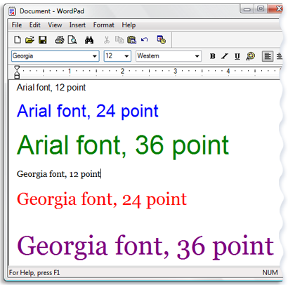

Saving your document
Saving means storing a document.

Steps
1. Click File menu
2. Click Save As.
3. In the Save in box, click the location where you want to save the document.
4. In the File name box, type a name for your document.
5. Click Save.

Printing your document
Printing means producing the typed work on a paper using a printer.
Steps
1. Click File menu
2. Click Print.
3. In the Print dialog box, use the Page Range box and the Number of copies box to specify which pages you want to print as well as how many copies.
4. Click Print.
Topical questions

1. What is WordPad?
WordPad is program you can use to create and edit documents.

2. What are the steps of opening WordPad?
a. Click Start button
b. Click All Programs / Programs
c. Click Accessories
d. Click WordPad.

3. How do I save a WordPad document for the first time?
- Click File menu
- Click Save As.
- In the Save in box, click the location where you want to save the document.
- In the File name box, type a name for your document.
- Click Save.

4. How do I print a WordPad document?

i. Click File menu
ii. Click Print.
iii. In the Print dialog box, use the Page Range box and the Number of copies box to specify which pages you want to print as well as how many copies.
iv. Click Print.

5. How do I insert the current a missed word into my document?
a. Click where you want to add the text.
b. Start typing.

6. How do I copy a text in WordPad?
- Select the text to copy.
- Click Edit menu
- Click Copy.
- Move the cursor to the place where you want to insert (put) the copied text.
- Click Edit menu
- Click Paste.

Bullets and Numbering
Steps
• Highlight the words you have typed.
• Choose Format from the menu bar.
• Choose Bullets and Numbering from the menu.
• Choose the Numbered tab.
• Several styles are available to you. Click the style you want to use.
• Click OK. Your list is now numbered.

Top of Form
KEYBOARD TYPING EXERCISES
Bottom of Form
The home row of the keyboard is the most important to the touch-typist.
When at rest the typist's fingers are positioned, lightly, on the A-S-D-F keys for the left hand,
and the J-K-L-; keys for the right hand.
- The left index finger will control the F and G keys, the right index finger will control the J and H keys.
- The left middle finger will control the D key, the right middle finger will control the K key.
- The left ring finger will control the S key, the right ring finger will control the L key.
- The left little finger will control the A key, the right little finger will control the ; key.
- The spacebar is controlled by the right thumb.

The home row.
LEFT HAND |  |  |  |  | RIGHT HAND
LF | RF | MF | IF | IF | IF | IF | MF | RF | LF
A | S | D | F | G | H | J | K | L | ;
LF = little finger, RF = ring finger, MF = middle finger, IF = index finger
The F and J keys often have small raised bumps on their tops, a tactile aid for the typist.
The locations of all the other keys on the keyboard are learned in relation to these home keys so the touch-typist must be able to find the home keys by touch.
Using the raised bumps on the F and J keys as a guide, see if you can put your fingers on the home row correctly, without looking at the keyboard. No peeking.
Make sure you are sitting up straight, your feet flat on the floor. Keep your elbows close to your body, your wrists straight and your forearms level, and remember – “take regular breaks.”
When you are ready to begin, select an exercise and strike the key requested. Try not to look at the keyboard. It will be difficult at first but as the exercise progresses you will find it becomes easier and your fingers will begin to move without you consciously deciding which finger is associated with which key.
You may find it helpful to quietly say the name of the key as you strike it.
Don't let your mistakes cause you to lose heart, touch typing is a skill that can be learned by practice.
Repeat each exercise at least three times.

Typing Reference - Fingering
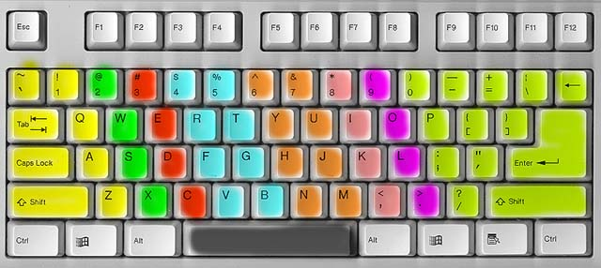

Key
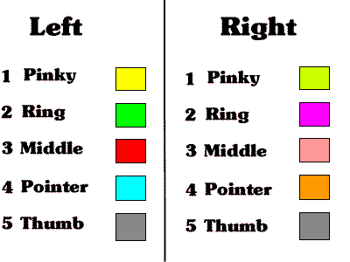

Ref: 1. Computers made easy
2. Computer studies Bk 2
3. Internet

